**Data Science Lab # 1**

**Roll no: 20K-0409**

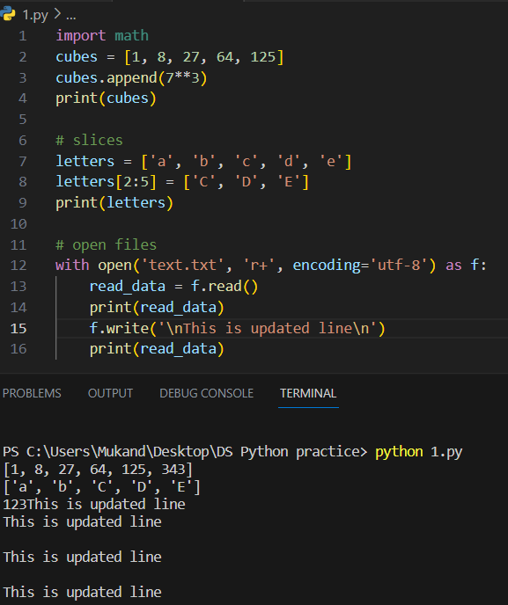

**Task #1.**

**Task #2.**

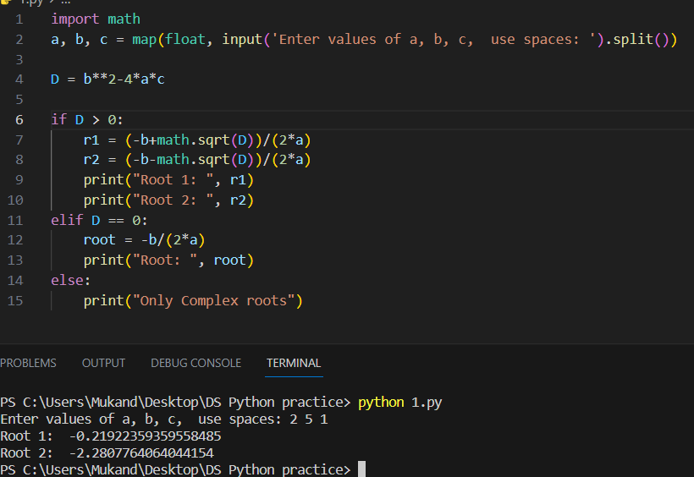

**Task #3**

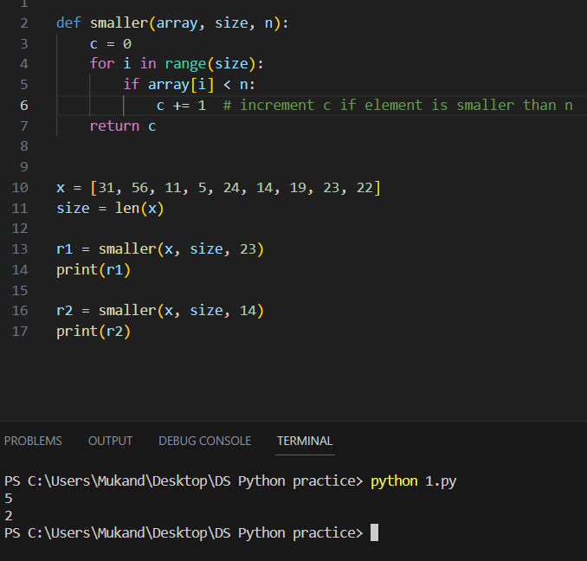

**TASK # 5**

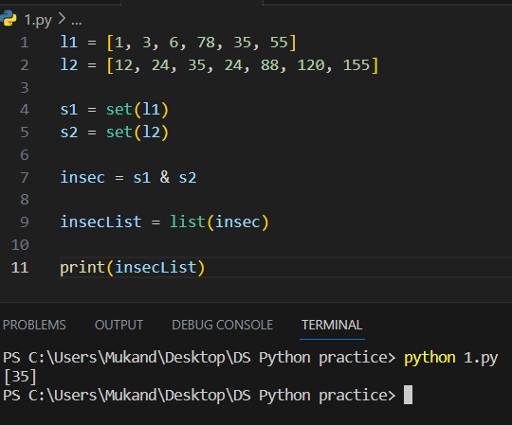

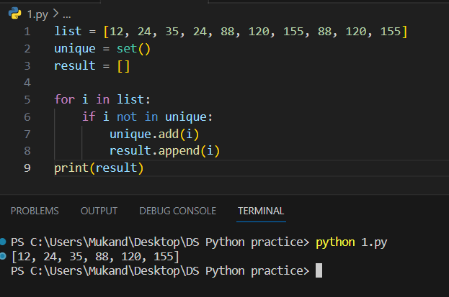**Task #4**

**TASK # 7**

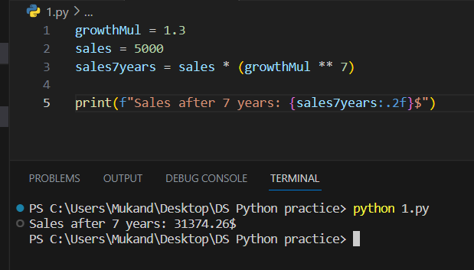

**Task #6**

**TASK # 8, 9, 10**

